CSS Layout - Flexbox – Exercise

Topics Covered
Flexbox is a one-dimensional layout method for arranging items in rows or columns. Items flex (expand) to fill additional space or shrink to fit into smaller spaces. This article explains all the fundamentals.

Resources
- Flexbox MDN
  - https://developer.mozilla.org/en-US/docs/Learn/CSS/CSS_layout/Flexbox
- A Complete Guide to Flexbox
  - https://css-tricks.com/snippets/css/a-guide-to-flexbox/
- An Interactive Guide to Flexbox
  - https://www.joshwcomeau.com/css/interactive-guide-to-flexbox/
- Flexbox cheat sheet
  - https://codepen.io/kdankov/pen/QWoVyZJ

Tasks

Layout – 3 columns
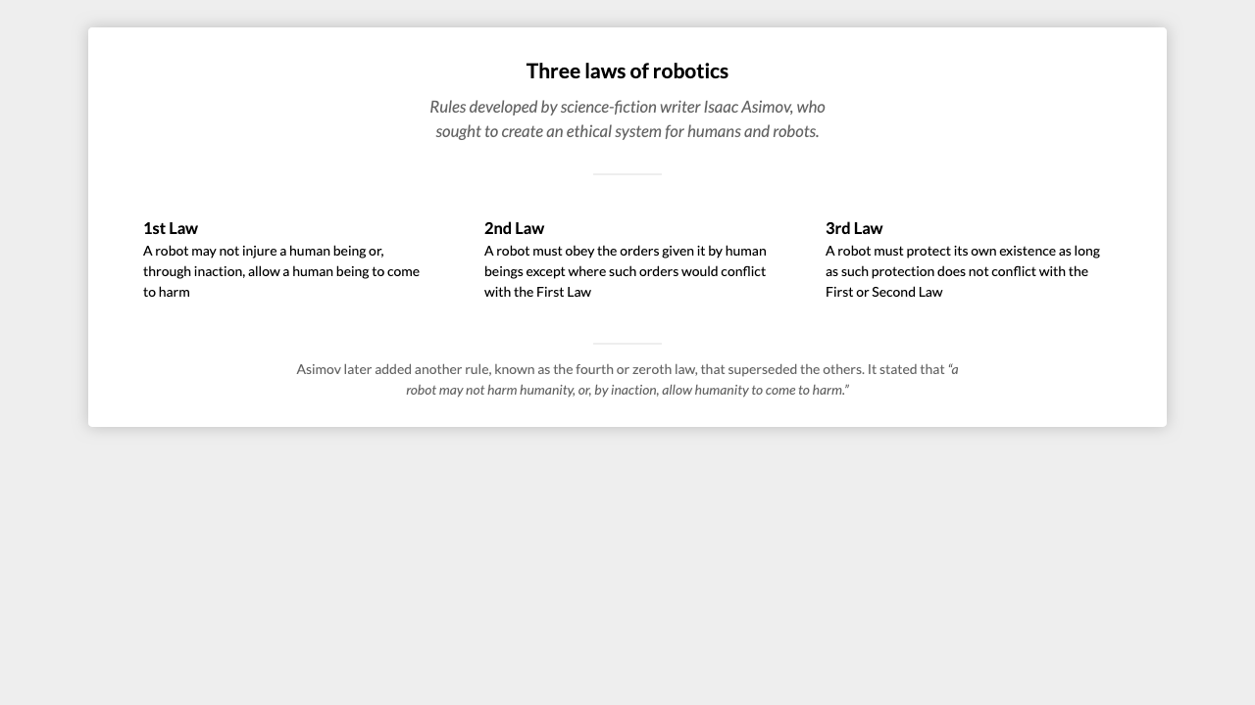
For full screenshot check the screenshot.png file in the folder for the task

Objective:
Create a webpage that looks like the screenshot above.

Requirements:
- File Setup:
  - Create an HTML document named three-columns.html
  - Create a CSS file named three-columns.css

Flex order
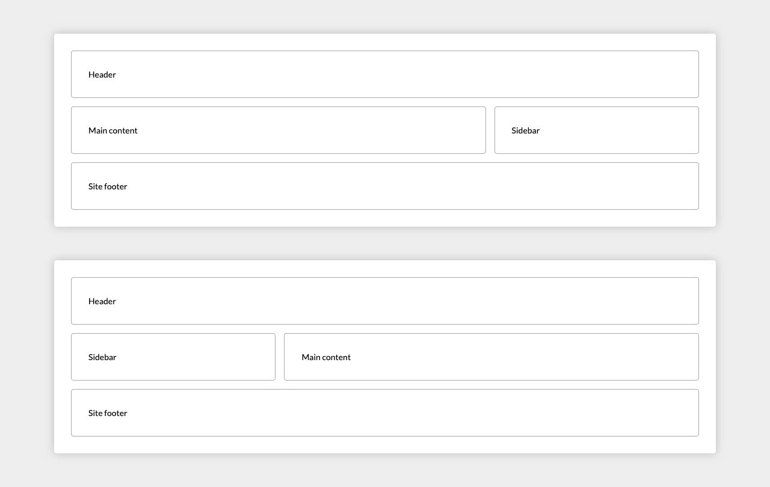
For full screenshot check the screenshot.png file in the folder for the task

Objective:
Create a webpage that looks like the screenshot above.

Requirements:
- File Setup:
  - Create an HTML document named flex-order.html
  - Create a CSS file named flex-order.css

Calendar
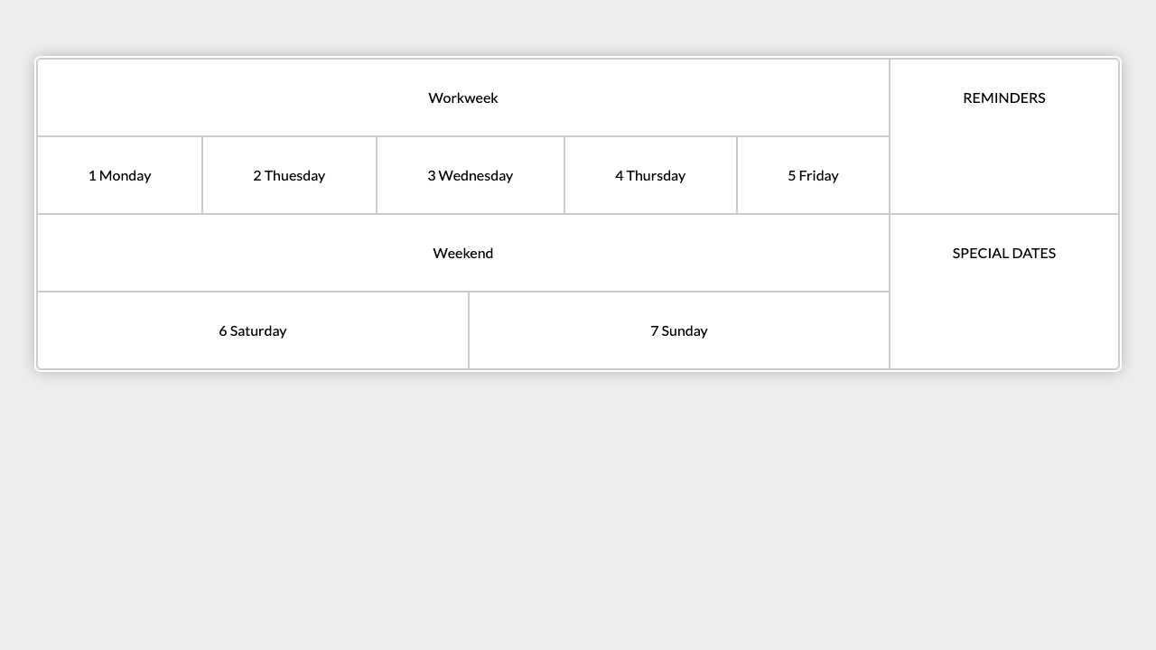
For full screenshot check the screenshot.png file in the folder for the task

Objective:
Create a webpage that looks like the screenshot above.

Requirements:
- File Setup:
  - Create an HTML document named calendar.html
  - Create a CSS file named calendar.css

Main Navigation
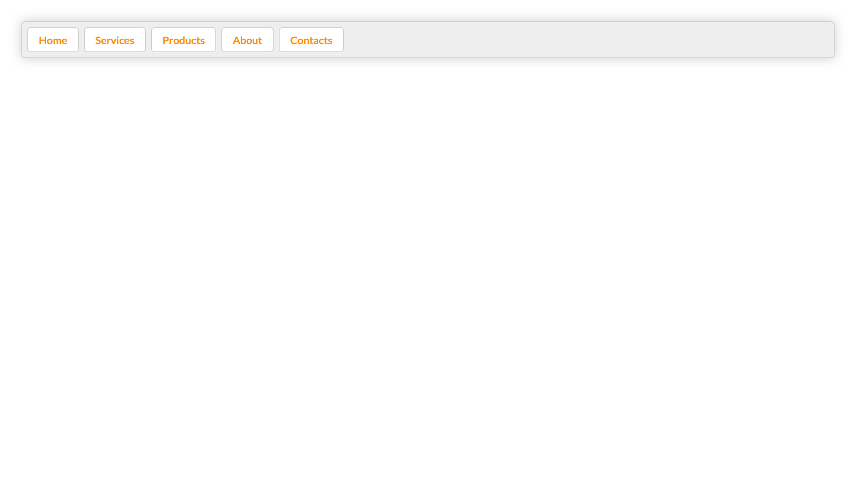
For full screenshot check the screenshot.png file in the folder for the task

Objective:
Create a webpage that looks like the screenshot above.

Requirements:
- File Setup:
  - Create an HTML document named main-navigation.html
  - Create a CSS file named main-navigation.css

Photo Gallery
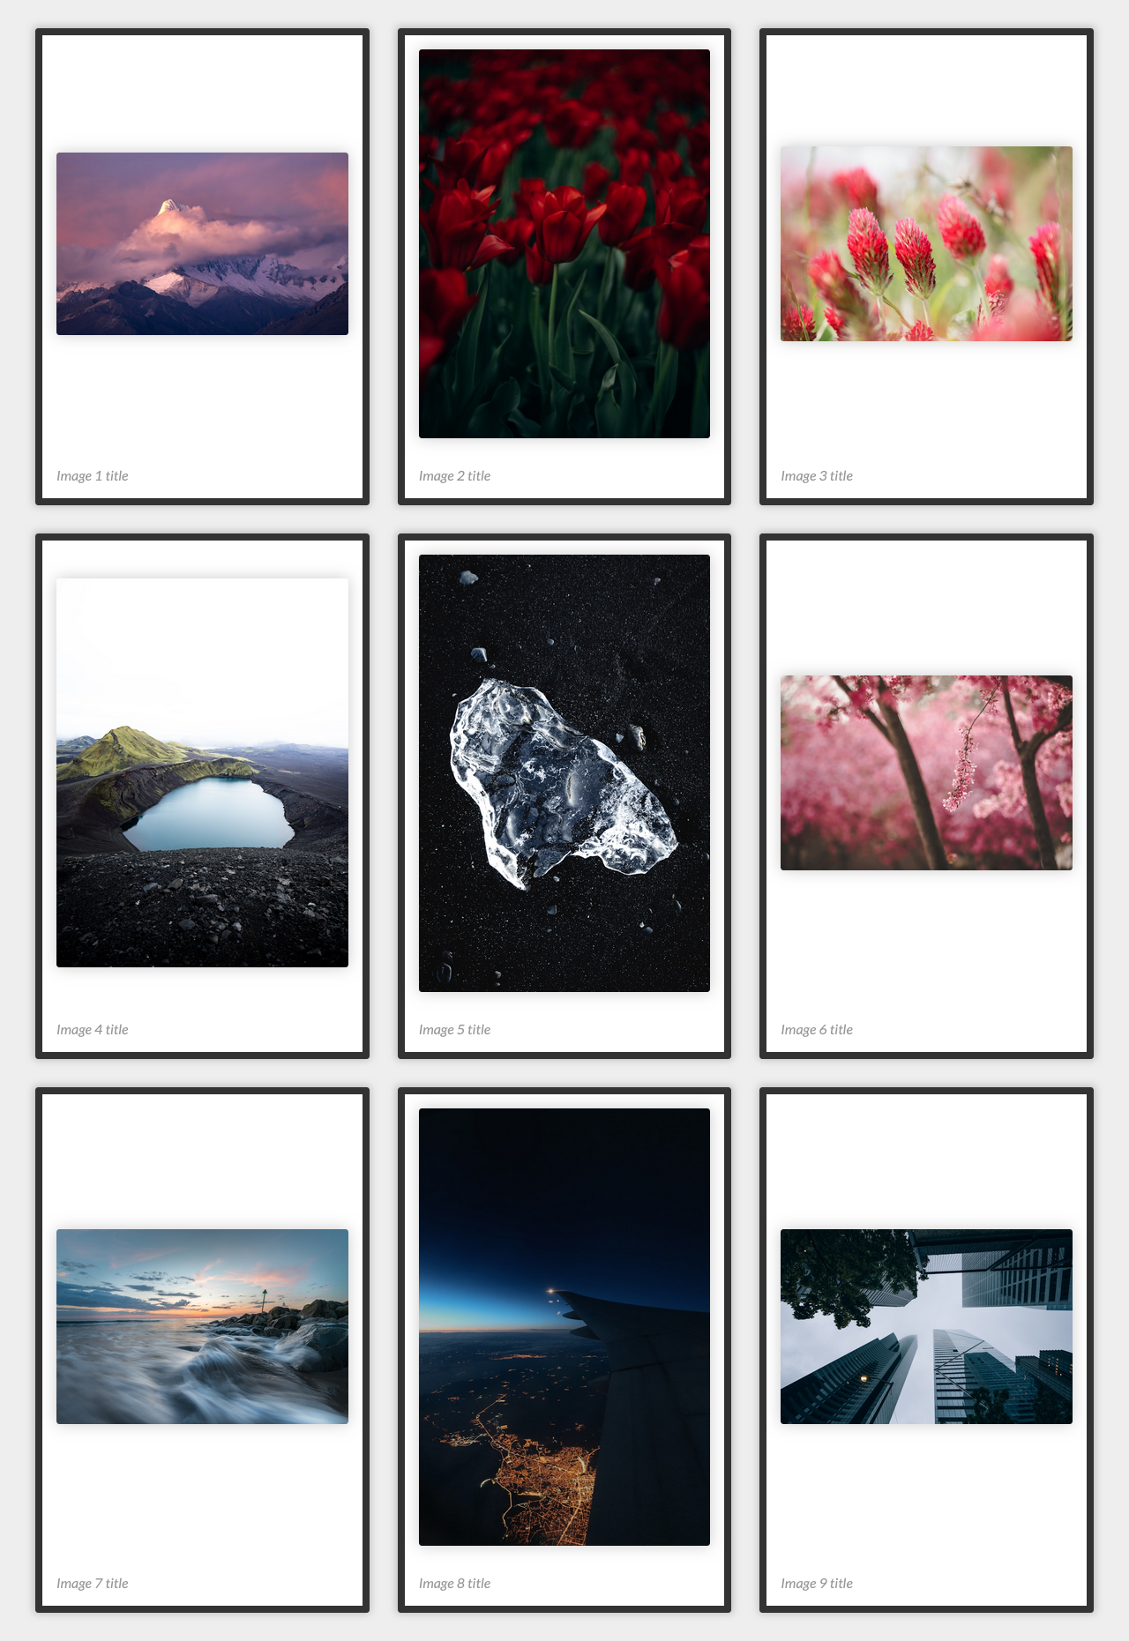
For full screenshot check the screenshot.png file in the folder for the task

Objective:
Create a webpage that looks like the screenshot above.

Requirements:
- File Setup:
  - Create an HTML document named photo-gallery.html
  - Create a CSS file named photo-gallery.css
- Fancy Quotes
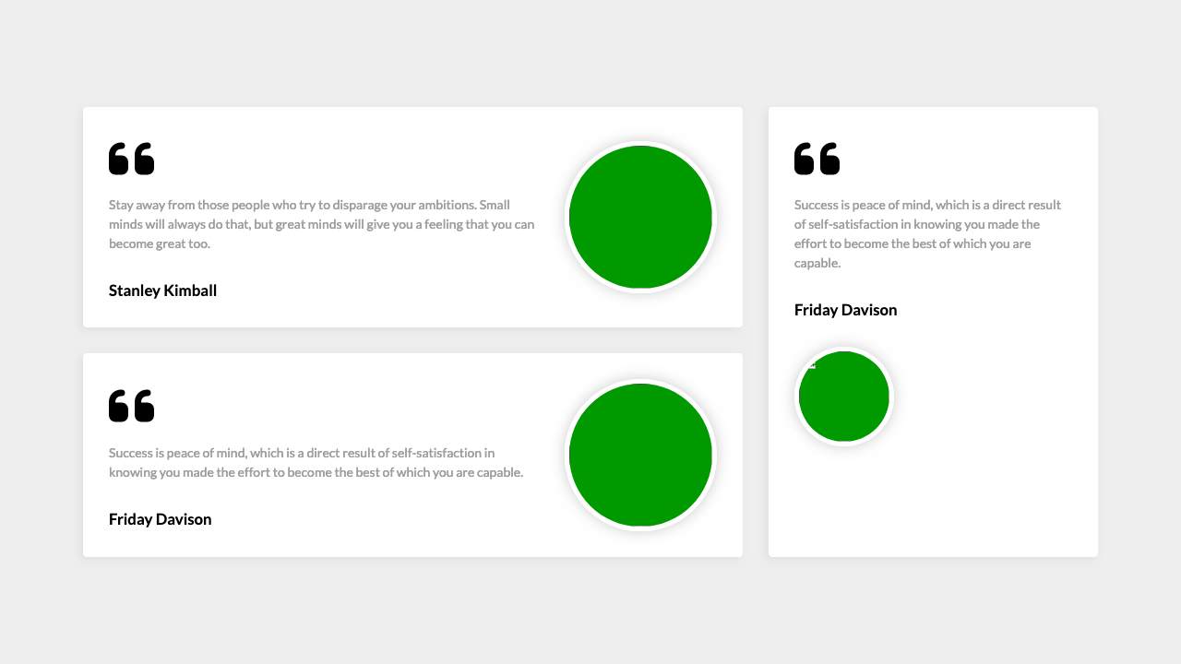
For full screenshot check the screenshot.png file in the folder for the task

Objective:
Create a webpage that looks like the screenshot above.

Requirements:
- File Setup:
  - Create an HTML document named fancy-quotes.html
  - Create a CSS file named fancy-quotes.css

Expandable Tree view
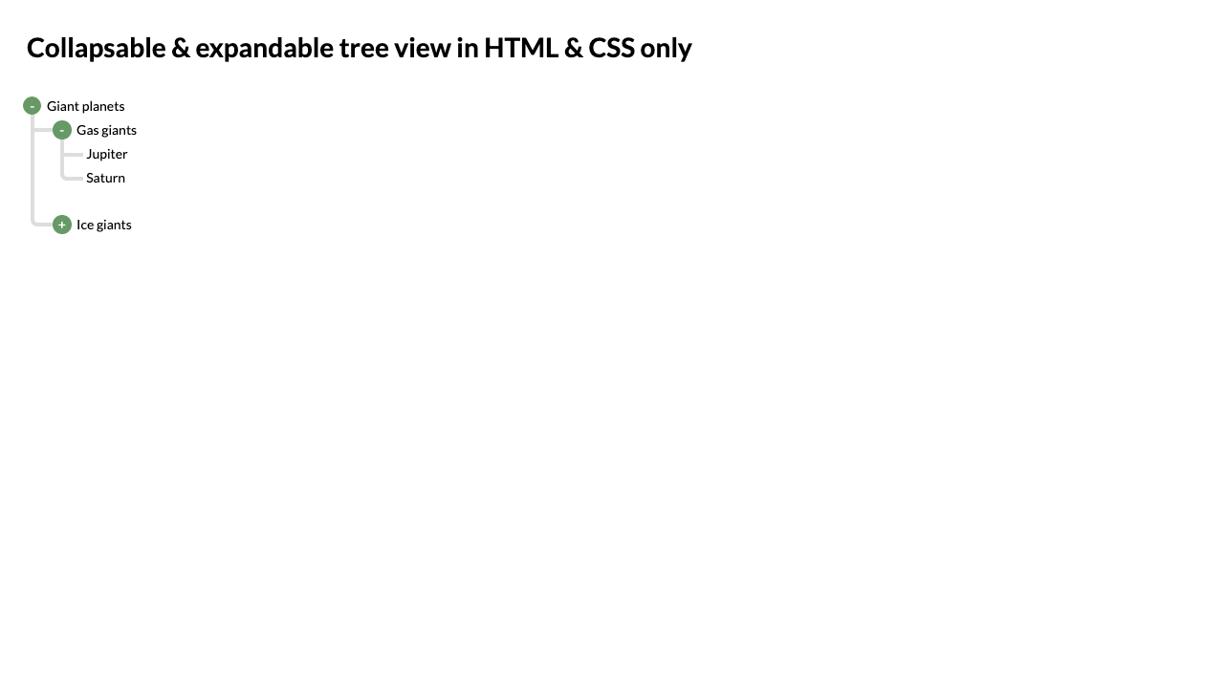
For full screenshot check the screenshot.png file in the folder for the task

Objective:
Create a webpage that looks like the screenshot above.

Requirements:
- File Setup:
  - Create an HTML document named expandable-tree-view.html
  - Create a CSS file named expandable-tree-view.css

Keyboard
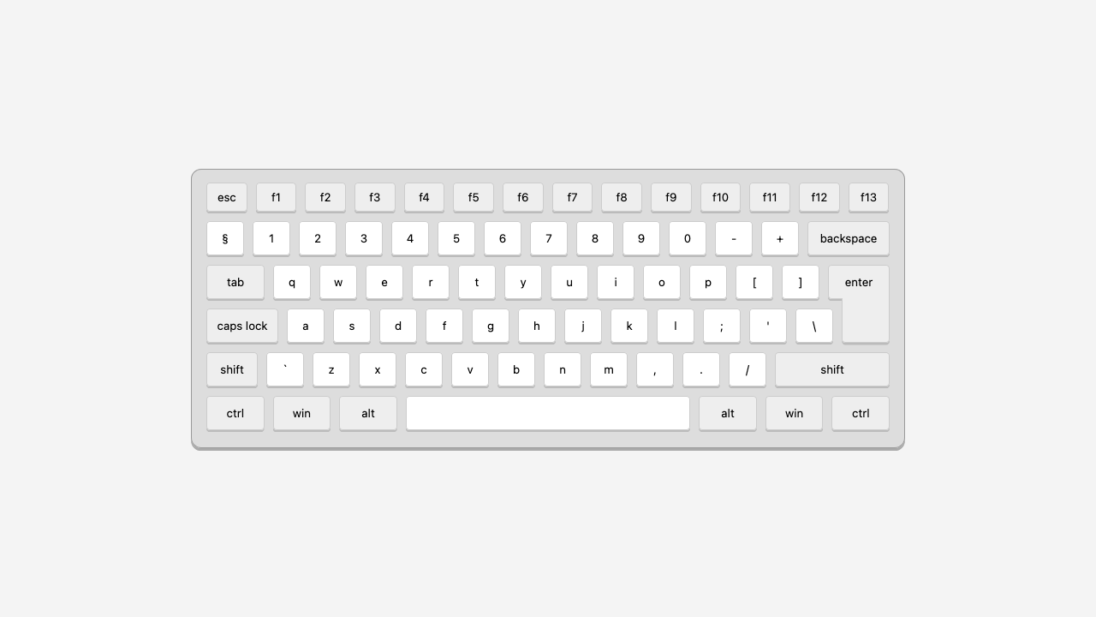
For full screenshot check the screenshot.png file in the folder for the task

Objective:
Create a webpage that looks like the screenshot above.

Requirements:
- File Setup:
  - Create an HTML document named keyboard.html
  - Create a CSS file named keyboard.css

Flexbox Center
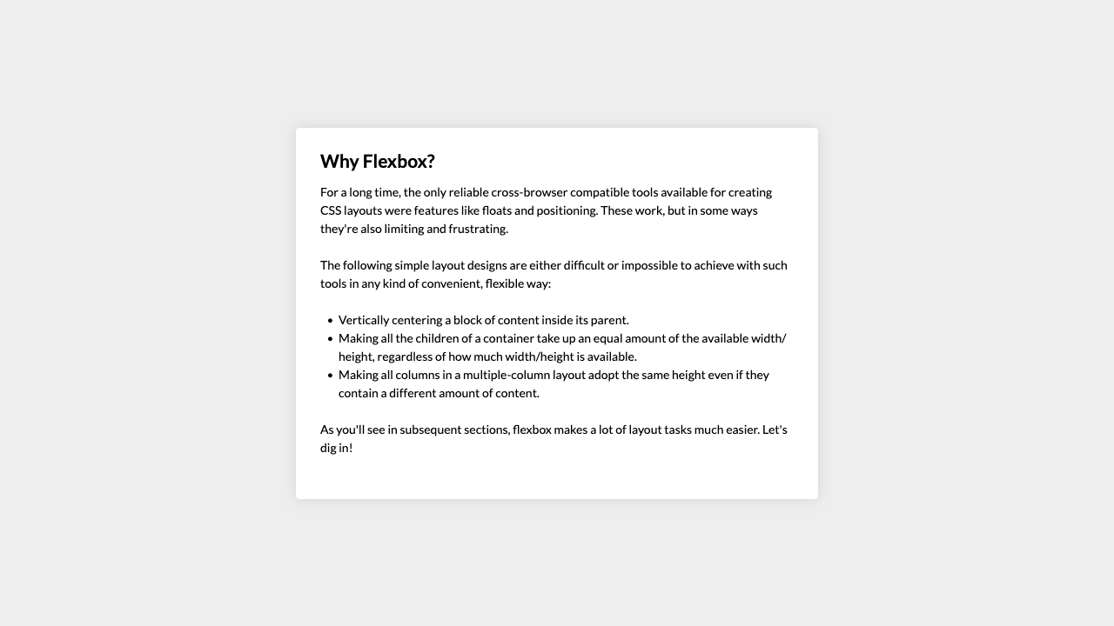
For full screenshot check the screenshot.png file in the folder for the task

Objective:
Create a webpage that looks like the screenshot above.

Requirements:
- File Setup:
  - Create an HTML document named flexbox-center.html
  - Create a CSS file named flexbox-center.css

Layout Sticky Footer
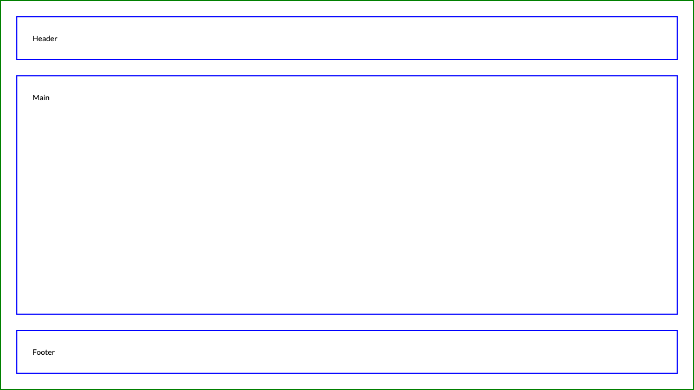
For full screenshot check the screenshot.png file in the folder for the task

Objective:
Create a webpage that looks like the screenshot above.

Requirements:
- File Setup:
  - Create an HTML document named sticky-footer.html
  - Create a CSS file named sticky-footer.css

Section Banner
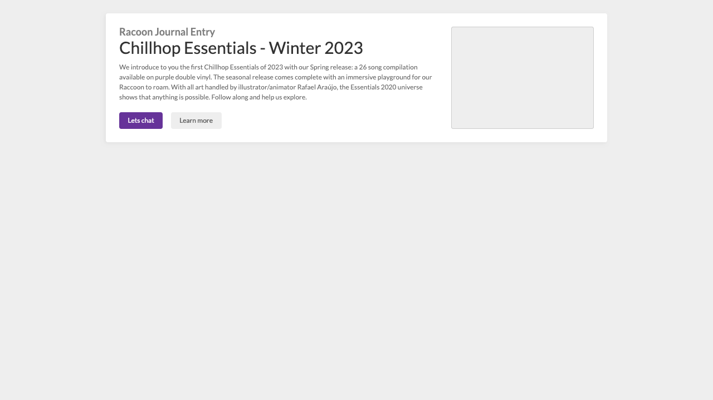
For full screenshot check the screenshot.png file in the folder for the task

Objective:
Create a webpage that looks like the screenshot above.

Requirements:
- File Setup:
  - Create an HTML document named section-banner.html
  - Create a CSS file named section-banner.css

